City, University of London

BSc Computer Science

Final Year Project Report

Academic Year: 2025-2026

TFL Underground Analysis

Author:
Mohammad Faisal

Project Supervisor
Warren Fernando | Warren.Fernando@city.ac.uk

Abstract

A deeper analysis of the London underground data starting for 2004 to 2017. The aim is streamline the data and make sure non technical users benefit from this.

I have sourced the data from the London Datastore(a reliable data platform)

I have built a web application that allows users to view the unstructured data in a clean and structured manner by using all sorts of charts such as Bar chart, line chart, z score shart and etc

Contents
1. Introduction 4
1.1 Problem to be Solved 5
1.2 Project Objectives 5
7.References 6

Introduction
This project addresses the fundamental problem of accessing unstructured data published by Transport for London (TfL) in the form of Excel files. Anyone wishing to access this data for professional purposes such as journalists writing reports and articles, urban planners conducting analysis, or students researching transport systems, encounters significant barriers in making the data readable and actionable.
After researching existing solutions, I found that current software tools do not adequately address this accessibility problem. For instance, while Google Maps provides real-time data for commuters, it is designed for passenger convenience rather than analytical research. My project targets a different user group entirely: journalists, urban planners, and students who need to work with historical operational data for research, policy analysis, and academic purposes.
The London Underground is one of the busiest public transport systems in the entire world. The first line opened in 1863 between Paddington and Farringdon, and the mobility provided by the Underground fundamentally shaped London's development into one of the world's leading cities. Every year, TfL publishes operational performance data including footfall by station, service delays, lost customer hours, and customer satisfaction survey scores. However, this data publication framework was discontinued following the COVID-19 outbreak. The fundamental problem remains: this data is largely inaccessible to non-technical users who rely on Excel and cannot use specialized software to visualize and analyze the data effectively.
My project solves this by building a complete data pipeline: I clean unstructured TfL data using the Python Pandas library, transport the cleaned data to PostgreSQL (a powerful relational database for analysis and querying), and finally visualize the results using Python Streamlit combined with Plotly for interactive charts and insights.
This report presents the motivation, design, implementation, analysis, and evaluation of the developed system.

1.1 Problem to be Solved
The messy data problem became obvious the moment I opened the source files. The tables were extremely large, it was easy to get lost just trying to find one thing, and there were many empty rows that could have led to incorrect conclusions. On top of that, the format was horizontal, which made the data even harder to work with.
The three main beneficiaries of this project are urban planners, journalists, and students. After thinking about these groups and doing some research, I came to the conclusion that many of them may not have a strong technical background, which means they would likely find it difficult to interpret the data and make practical use of it.
Existing solutions such as Power BI or Google Maps are useful at a surface level, but when it comes to drawing deeper insights, these tools either struggle or were simply not designed with this specific scope in mind.
The scope of this project is to streamline the process of accessing and understanding the data. I will not go into machine learning models or provide real-time insights. For real-time insights, TfL has already made its Open API available, which serves that purpose well.

1.2 Project Objectives
The primary objective is to create an accessible, interactive web-based dashboard that enables non-technical stakeholders to explore 14 years of London Underground operational data and extract meaningful insights without requiring expertise in data analysis or programming.
A brief summary of the project objectives is listed below and has been adapted from the Project Definition Document in Appendix A. Please refer to the PDD in Appendix for a detailed list of objectives.
- Database Design and Implementation
I designed and developed a relational database in PostgreSQL to store the cleaned data and analyse using SQL statement
- Data Ingestion Pipeline
I used Python Pandas library to clean the unstructured CSV files I got as a source and shipped the data to PostgreSQl table
- Web Application and User Interface
I used Streamlit and present the findings in a clean and consistent manner.
- Data Visualization
Plotly was used to visualise the findings by presenting the analysis using graphs.

1.3 Planned work
I had very less experience of working with data and I was only skilled in SQL prior to working in this project. It was important that I choose the correct and adequate tech stack that is both easy and does not cost me to change the objective of the project or limits significantly to what I intend to achiev with this project.
I need to find a tool that helps me convert those messy and unstructured csv files and I chose Python Pandas as it turned out be the best out there for this purpose. Cleaning CSV was an important part of the project as I intended to use SQL for the analysis and the data in csvs was not in the right format for the sql to work with.
I chose psycopg2 and not SQL alchemy because psycopg2 is more suitable for developers who want to work with PostgreSQL later on( GeeksForGeeks comparison - https://www.geeksforgeeks.org/python/difference-between-psycopg2-and-sqlalchemy-in-python/). I used the Geeksfor Geeks comparison to decide as it gave me a transparent comparison between the two libraries.
The decision to use PostgreSQLwas purely dependent on the analysis as PostgreSQL had a vast set of materialised views and views were crucial to my project. Again I used GeeksforGeeks comparison to come a decision of using this.
Lastly, Streamlit was the only library easy to understand and implement the web application.
Details on the methodology can be found in the later sections

Output summary
The Streamlit Dashboard:
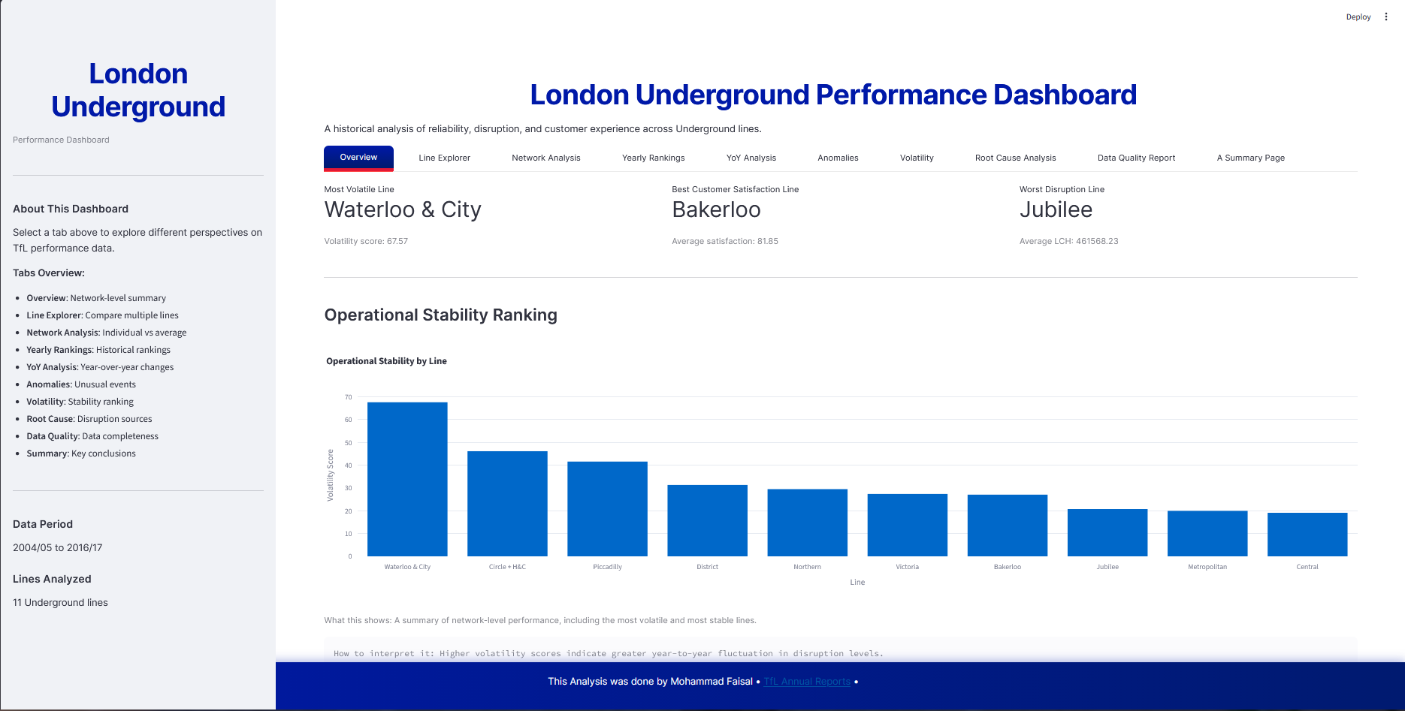
As you can see the dashboard above. This is the main output of the project.On the left is a summary of all the tabs you see here. You can explore the trends over the couse of 14 years as a line graph per line and you can also filter the lines using the filter given. There are total 10 tabs each withs its own functionality. Tab 10 is has the most important feature which is linking all the numbers and data to a real world context using the TFL’s annual reports published each year. This feature was the main highlight of the project and gives context on how real life factors affected the data.

Methodology
The approach I used in this project was simple, I researched for reliable and authentic data source where I found a website called London DataStore. This website is a government website where every department in London uploads their data. I chose to use the London Underground Performance Data.
This one file contained enough information for me to do the analysis. I built this project in three stages. The first and foremost stage was cleaning and structuing of the excel files which were done using Pandas and I used psycopg2 to connect the Csvs to the PostgreSQL database. This stage also comprised of smaller tasks such as writing CREATE table statements, using melt() function to change the overview of the data and then finally INSERT INTO statements for insertion of data.

Second stage was the the most crucial stage as the whole objective of this project was dependent on it. I initially thought of using ML but then quickly realized it was a scope creep and dropped it. I found a powerful function in SQL that were adequate for my job. I used analytical views, window functions and LAG.

Third stage was presenting my findings in a clean and consiten UI. I used streamlit for the web app and plotly for graphs

7. References

- Transport for London (2024) Open Data Policy. Available at: https://tfl.gov.uk/info-for/open-data-users/open-data-policy/ (Accessed: 20 March 2026).
- Transport for London (2024) London's Transport: A History - London Underground. Available at: https://tfl.gov.uk/corporate/about-tfl/culture-and-heritage/londons-transport-a-history/london-underground (Accessed: 20 March 2026).
- Greater London Authority (2024) London Datastore. Available at: https://data.london.gov.uk/ (Accessed: 20 March 2026).

